k
Object Orientend Programming
with C++
(
CSE
-2001)
PRACTICAL FILE
Name : Adhikari Viswa Teja
Reg n.o : 24MIM10138
Submitted to : Dr. Dhereesh Soni
Slot :A11+A12+A13
:
Introduction to
Problem Solving
(
CSE
1021)
Project Title
Task Management
System
Name : SUVVADA HEMANTH HEMANTH
Reg n.o : 26MIM10073
Submitted to : Dr. Pricilla Dinkar moya
:Slot:B11+B12+B13+C14+E11+E121212:BBBHJJ::HRBFJBBBFKRFBKL::B11+B12+B13+C14+E::”:GGUYYHHHHB12
1.Introduction:
The To-Do List Application is a command-line project designed to help users efficiently manage daily tasks. Users can add tasks, set due dates, mark completion status, and delete tasks. The app ensures basic task organization and showcases core Python concepts such as loops, lists, dictionaries, functions, and date handling.
This project is ideal for beginners and demonstrates how Python can be used to build simple yet effective real-world applications.
2.Problem Statement:
People often forget important tasks or deadlines because they do not have a simple way to track and organize them. Many to-do list applications are too complex for beginners or require internet access.
There is a need for an easy, offline, and beginner-friendly task management system that runs on any device with Python installed.
.

3.Functional Requirements
- Add a new task
Allows the user to enter a task along with its due date. The task is stored in the task list for later retrieval.
- View all tasks
Displays the complete list of tasks with their status and due dates. Helps the user see all pending and completed tasks together.
- Mark task as completed
Lets the user change a task’s status from pending to completed. Useful for tracking progress and what tasks are done.
- Delete a task
Allows the user to remove any task from the list permanently. Helps maintain a clean and updated task list.
- View pending tasks only
Shows only the tasks that are not yet completed.
Makes it easier to focus on tasks that still need attention.
- Exit the application
Closes the program safely without losing data during the session.
Provides a clean termination of the user workflow.

4.Non-functional Requirements
Usability: Interface must be simple and text-based.
Reliability: The system should not crash due to user errors.
Performance: All operations must be fast and responsive.
Portability: Should run on Windows, Linux, Android (with Pydroid/Termux).
Maintainability: Code should be modular and readable.
Scalability: Easy to add new features in the future

5.System Architecture
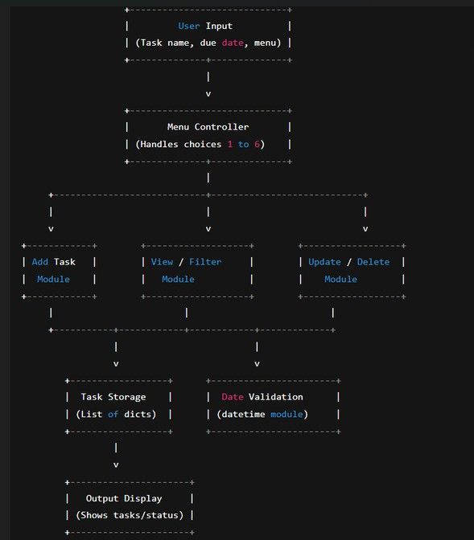

6.Design Diagram
a)Use Case Diagram: 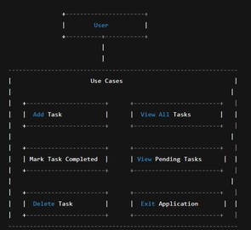
b)Workflow Diagram:
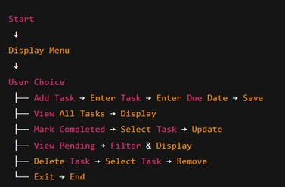
c)Sequence Diagram:
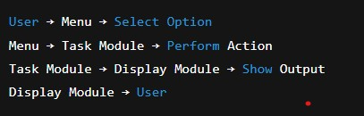
d)Class Diagram: 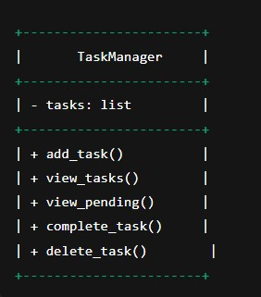

7.Design Decisions and Rationale
Use of Python
Simple, powerful, easy for beginners
CLI interface
Works everywhere, no GUI needed
Lists + dictionaries
Best for storing structured task data
Due date input
Makes tasks more realistic
Modular functions Easier to maintain and expand

8.Implementation Details
- Language: Python 3 • Modules used:
datetime (for due dates) • Core Concepts Used:
Lists
Dictionaries
Loops
Functions
Conditionals
- File: todo.py
Each function handles a separate part of the application:
add_task() → task creation view_tasks() → display complete_task() → mark complete delete_task() → remove task view_pending_tasks() → filter tasks

9.Screenshots
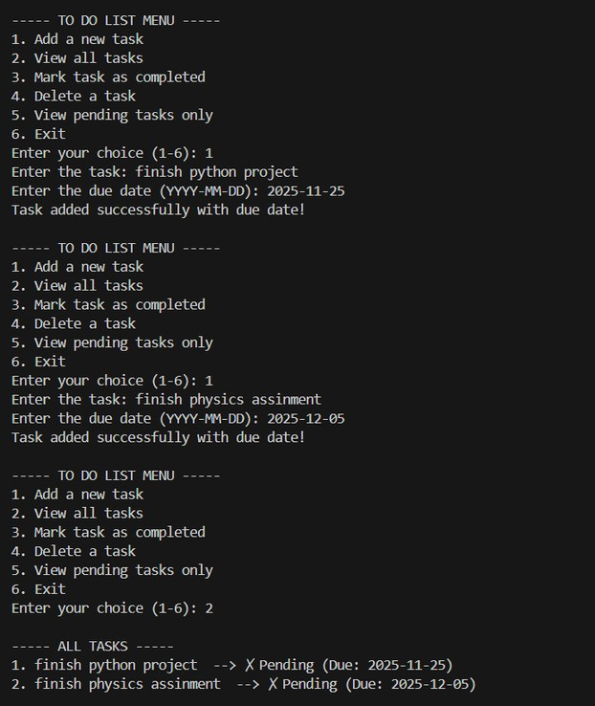
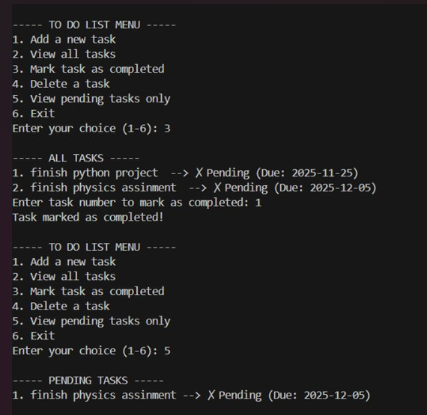

10. Testing Approach
Functional Testing
Check each menu option works correctly
Input Validation
Test valid/invalid dates
Boundary Testing
Empty list, first & last task
Error Handling
Wrong menu input, invalid task number

11.Challenges Faced
Ensuring correct date format
Handling invalid inputs without crashing
Managing a list of tasks dynamically
Making the interface simple but effective Avoiding duplicate code by using functions

12. Learnings & Key Takeaways
How to create modular Python programs
Usage of lists and dictionaries
Input handling and validation
Basics of software development lifecycle
How to design a simple text-based system
Understanding due dates with datetime

13. Future Enhancements
Save tasks permanently using file storage
Load tasks when program starts
Add notifications or alerts for overdue tasks
Add priority levels (High/Medium/Low)
Implement a GUI using Tkinter
Add color-coded terminal output
Cloud sync and user login (advanced)

14. References
Python Official Documentation: https://docs.python.org/
W3Schools Python: https://www.w3schools.com/python/
GeekForGeeks Python: https://www.geeksforgeeks.org/python/
Project design ideas adapted from standard SDLC practices

